**GIT**

**GitHub Basics with Commands and Descriptions :**

**1. Setup**

**2. Create/Clone a Repository**

**3. Add and Commit Changes**

**4. Push and Pull Changes**

**5. Branching**

**6. View History**

**7. Undo Changes**

**8. Collaborating**

**9. Use .gitignore**

**10. Check Repository State**

**INDEX**

**1. Setup**

1. Install Git:
2. Configure Git:

**2. Create/Clone a Repository**

1. Initialize a local repository:
2. Clone a repository:

**3. Add and Commit Changes**

1. Check status:
2. Stage changes:
3. Commit changes:

**4. Push and Pull Changes**

1. Connect local repo to GitHub:
2. Push changes to GitHub:
3. Pull changes from GitHub:

**5. Branching**

1. Create a new branch:
2. Switch to a branch:
3. Create and switch to a new branch:
4. Merge a branch into main:

**6. View History**

1. View commit history:
2. Show a summary of changes:

**7. Undo Changes**

1. Unstage changes:
2. Discard uncommitted changes:

**8. Collaborating**

1. Fork a repo (on GitHub):
2. Create a pull request:

**9. Use .gitignore**

1. Ignore files or folders:

**10. Check Repository State**

1. Check remote repositories:
2. View differences:

**\*\*\***

**1. Setup**

1. Install Git:

Download from<https://git-scm.com/>.

1. Configure Git:

Set your username and email globally:

**# Set your name**

git config --global user.name "Your Name"

**# Set your email**

git config --global user.email "your.email@example.com"

**2. Create/Clone a Repository**

1. Initialize a local repository:

git init # Create a new repo in the current directory

1. Clone a repository:

**# Download an existing repo**

git clone https://github.com/username/repo-name.git

**3. Add and Commit Changes**

1. Check status:

git status # See changes and untracked files

1. Stage changes:

**# Stage all files**

git add .

**# Stage a specific file**

git add file.txt

1. Commit changes:

**# Save a snapshot of your changes**

git commit -m "Your commit message"

**4. Push and Pull Changes**

1. Connect local repo to GitHub:

**# Link to GitHub**

git remote add origin https://github.com/username/repo-name.git

1. Push changes to GitHub:

**# Push your commits to the main branch**

git push -u origin main

1. Pull changes from GitHub:

**# Sync the latest changes**

git pull origin main

**5. Branching**

1. Create a new branch:

**# Create a branch**

git branch branch-name

1. Switch to a branch:

**# Move to a branch**

git checkout branch-name

1. Create and switch to a new branch:

**# Shortcut for creating and switching**

git checkout -b branch-name

1. Merge a branch into main:

**# Switch to main branch**

git checkout main

**# Merge changes from another branch**

git merge branch-name

**6. View History**

1. View commit history:

**# Show commit history**

git log

1. Show a summary of changes:

**# Compact view of commit history**

git log --oneline

**7. Undo Changes**

1. Unstage changes:

**# Unstage a file**

git reset file.txt

1. Discard uncommitted changes:

**# Reset file to last commit state**

git checkout -- file.txt

**8. Collaborating**

1. Fork a repo (on GitHub):

Create your copy of someone’s repo.

1. Create a pull request:

Propose your changes for review (via GitHub website).

**9. Use .gitignore**

1. Ignore files or folders:

Create a .gitignore file in your repo and add patterns to exclude:

node_modules/

.env

*.log

**10. Check Repository State**

1. Check remote repositories:

# See linked repositories

git remote -v

1. View differences:

# Compare working changes

git diff

Git Basic Video : https://www.youtube.com/watch?v=AdzKzlp66sQ

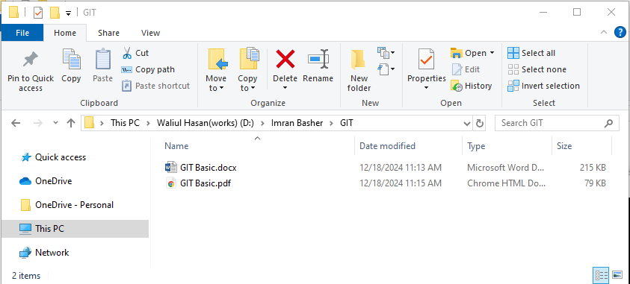

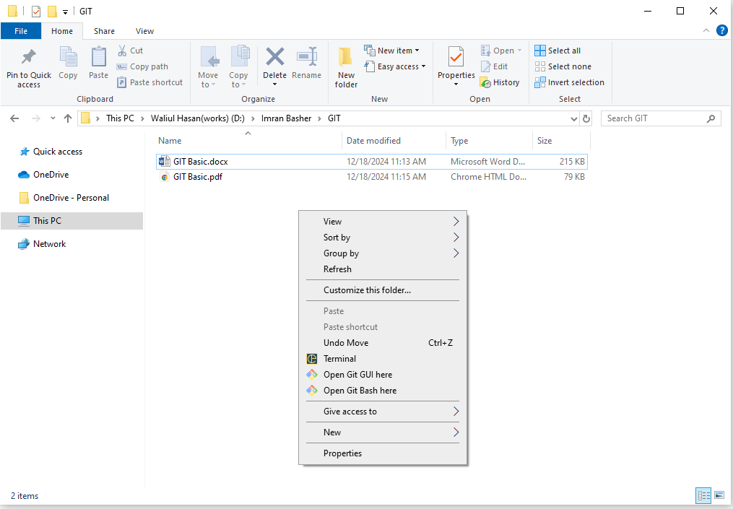

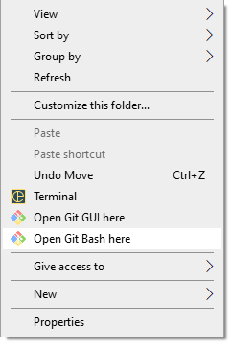

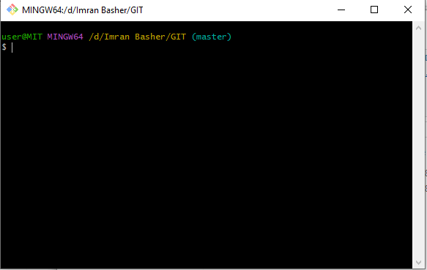

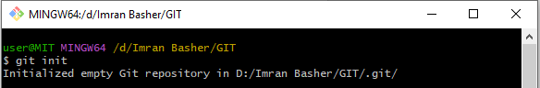

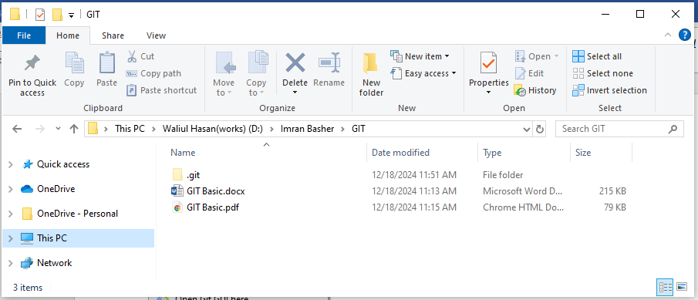

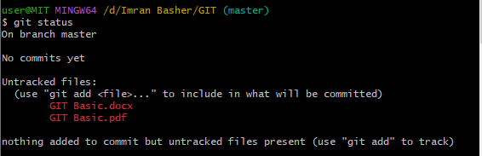



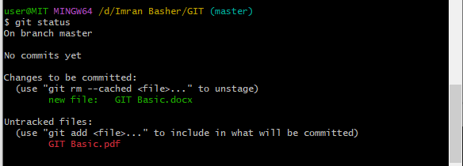

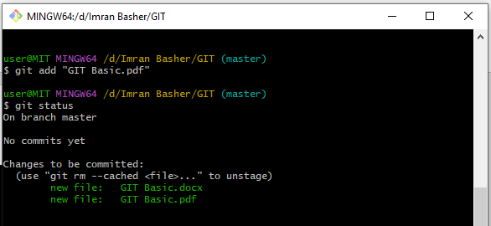

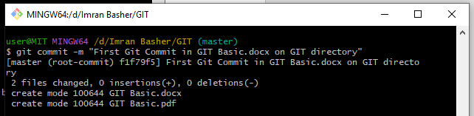

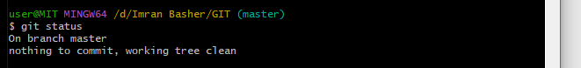

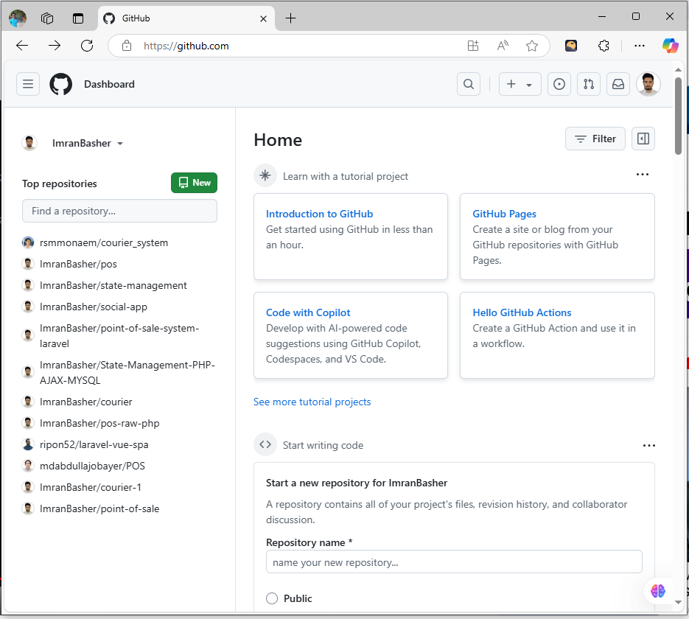

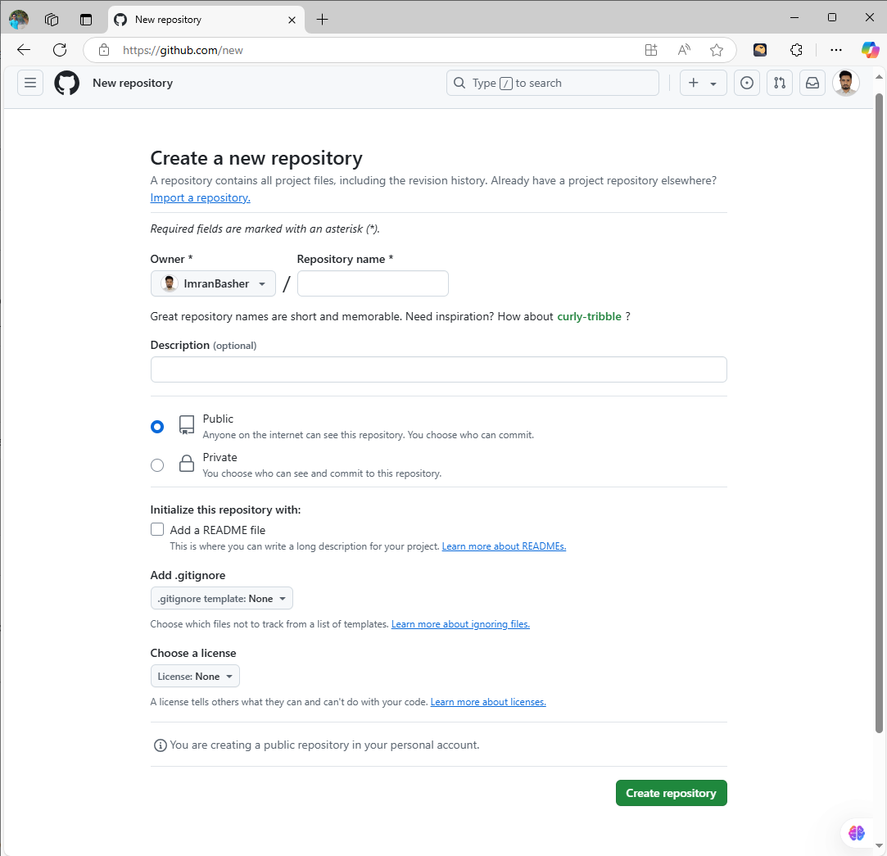

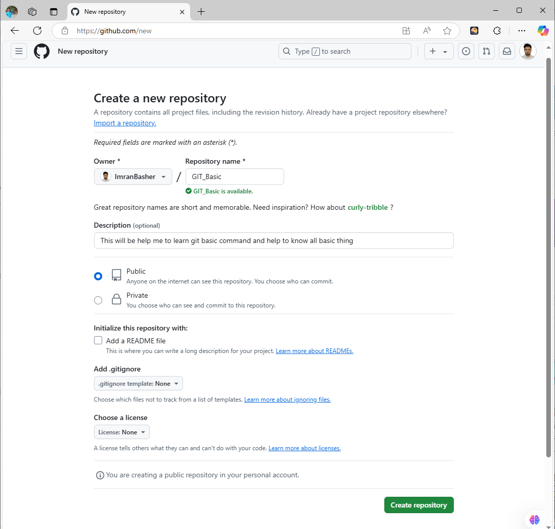

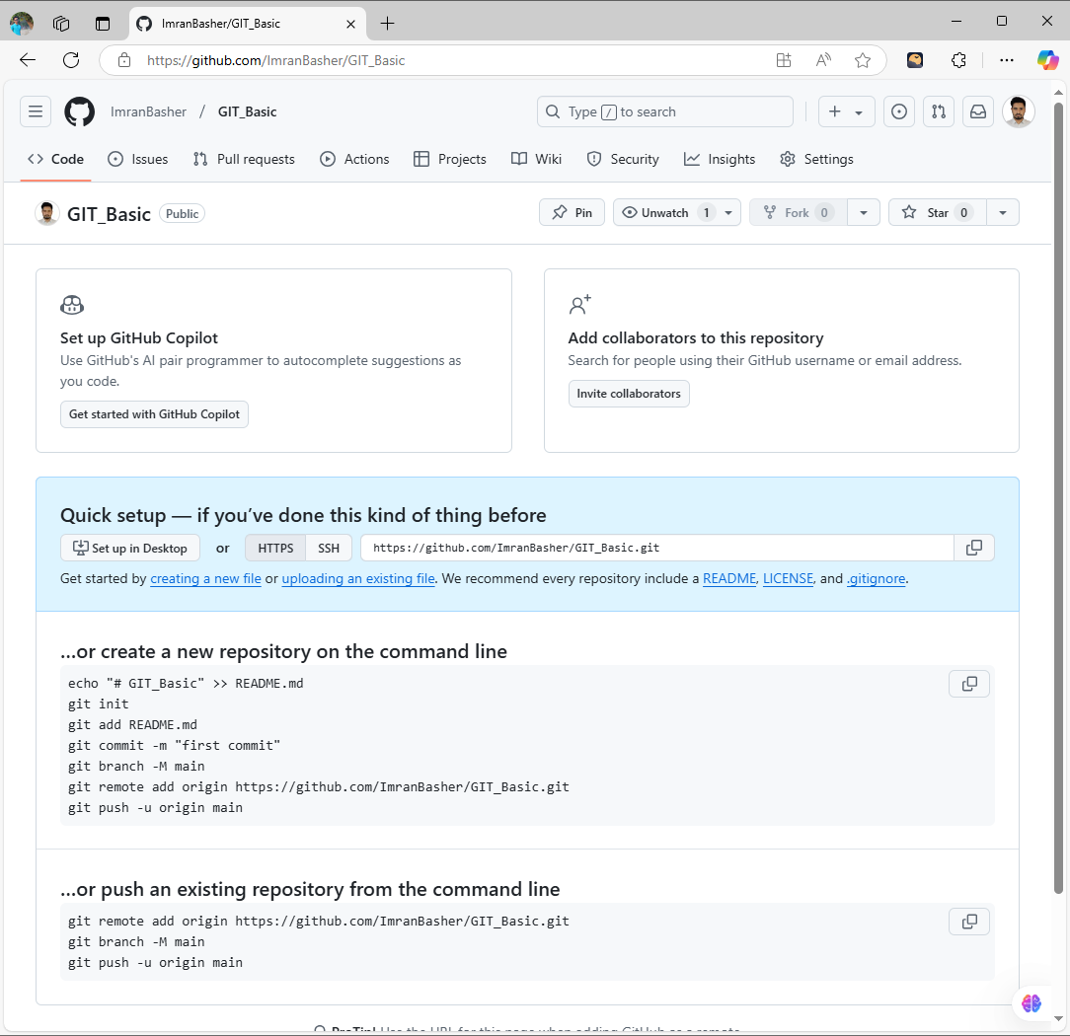





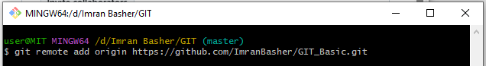

Configuration:

